**Integrating the Healthcare Enterprise**



**IHE Patient Care Coordination**

**Technical Framework Supplement**

**Cross Enterprise TeleHomeMonitoring Workflow Definition Profile**

**(XTHM-WD)**

**Trial Implementation**

Date: October 4, 2013

Author: IHE PCC Technical Committee

Email: pcc@ihe.net

**Foreword**

This is a supplement to the IHE Patient Care Coordination Technical Framework V9.0. Each supplement undergoes a process of public comment and trial implementation before being incorporated into the volumes of the Technical Frameworks.

This supplement is published on October 4, 2013 for Trial Implementation and may be available for testing at subsequent IHE Connectathons. The supplement may be amended based on the results of testing. Following successful testing it will be incorporated into the Patient Care Coordination Technical Framework. Comments are invited and may be submitted at [http://www.ihe.net/PCC_Public_Comments](http://www.ihe.net/PCC_Public_Comments/).

This supplement describes changes to the existing technical framework documents.

“Boxed” instructions like the sample below indicate to the Volume Editor how to integrate the relevant section(s) into the relevant Technical Framework volume.

Amend section X.X by the following:

Where the amendment adds text, make the added text bold underline. Where the amendment removes text, make the removed text bold strikethrough. When entire new sections are added, introduce with editor’s instructions to “add new text” or similar, which for readability are not bolded or underlined.

General information about IHE can be found at: [www.ihe.net](http://www.ihe.net).

Information about the IHE Patient Care Coordination domain can be found at: [http://www.ihe.net/IHE_Domains](http://www.ihe.net/IHE_Domains/).

Information about the organization of IHE Technical Frameworks and Supplements and the process used to create them can be found at: [http://www.ihe.net/IHE_Process](http://www.ihe.net/IHE_Process/) and [http://www.ihe.net/Profiles](http://www.ihe.net/Profiles/).

The current version of the IHE Patient Care Coordination Technical Framework can be found at: [http://www.ihe.net/Technical_Frameworks](http://www.ihe.net/Technical_Frameworks/).**CONTENTS**

Introduction to this Supplement 4

Open Issues and Questions 4

Closed Issues 4

**Volume 1 – Profiles 6**

X Cross Enterprise TeleHomeMonitoring Workflow Definition (XTHM-WD) Profile 6

X.1 Purpose and Scope 6

X.2 Process Flow 7

X.3 Workflow Participants and Process Flow 13

X.3.1 Use Cases 15

X.3.2 Options 33

X.3.2.1 Consult Request task without Telemonitoring task as ancestor Option 33

X.3.2.2 Clinical Input Option 34

X.4 Workflow Definition Actors and Options 35

X.4.1 Workflow Definition Actors 35

X.4.2 Workflow Options 35

X.4.3 Workflow Definition Profile Grouping with other Profiles 36

X.5 Security Considerations 38

**Volume 2 – Content Modules 39**

Y.1 XTHM Workflow Definition - XDW Workflow Document – Common Attributes 39

Y.2 XDW Content Modules 40

Y.3 Tasks Specifications 41

Y.3.1 Task: Request Activation 45

Y.3.2 Task: Approve Request 46

Y.3.3 Task: Telemonitoring 47

Y.3.4 Task: Consult Request 48

Y.3.5 Task: Analyze and Request Visit 49

Y.3.6 Task: Visit Result 50

Y.3.7 Task: Analyze and Change Protocol 51

Y.3.8 Task: NewProtocolActivation 51

Y.3.9 Task: Analyze and Take Clinical Action 52

Y.3.10 Task: Analyze and Take No Action 53

Y.3.11 Task: Close Telemonitoring Service 54

Y.4 Input and output documents 55

Appendix A - Complete example of Telemonitoring Workflow Document 56

Appendix B - Technical development of WD related to the telemonitoring process 68

B.1 Management of alarm situation with a request of a visit 68

B.2 Management of alarm situation with a change of the protocol 69

B.3 Management of alarm situation with clinical actions 70

B.4 Management of alarm situation with no actions 72

# Introduction to this Supplement

This supplement is written according to the specific template defined for Workflow Definition profiles. The structure of this document differs from a PCC Content Profile. In particular the XTHM-WD Profile establishes a common set of rules to share between participants involved in a telemonitoring workflow.

The telemonitoring process, and workflow related to it, is applicable to many different sharing infrastructures. In this profile we present a specific XDS based use-case.

Volume 1 is related to the introduction of the profile with the description of the telemonitoring process flow with the references to the tasks, to the produced documents and to the Workflow Participants involved in the process. This volume reports also the use case of the telemonitoring analyzing in details each possible step of the process.

Volume 2 aims to explain how to use XDW Workflow Document (See ITI Technical Framework and Supplements) to track and manage this workflow: in particular the detail features of each step of the workflow, and rules to follow to go through these steps are analyzed.

At the end of the supplement (Appendix A) is presented a complete example of a Workflow Document produced during a telemonitoring workflow; diagrams to provide a depiction of the technical development of the Workflow Document related to the telemonitoring are reported in Appendix B.

## Open Issues and Questions

None

## Closed Issues

* *(Reviewers should evaluate how to manage the task “Telemonitoring” in status FAILED. In general, the cardinality of this task is1..n but in the case where the status is FAILED, it should be required to be 2..n. After a “Telemonitoring” task is put in status FAILED (i.e., there are problems with sending data) there must be another “Telemonitoring” task with status COMPLETED (the measurement is repeated after the failure). Is there a need to specify this situation in the document? If yes, how can we describe it? (see table X.2-1 of Volume 2))* Answer: in case of failing of the Telemonitoring task it is not required to repeat the action traced but it is suggested to solve the problems in sending data adding new task Events.
* *(Reviewers should evaluate the need to define options within the Workflow Definition to facilitate implementation of the workflow definition profile. Should there be options on the (1) support of specific workflow tasks/status, (2) reference content document profiles, (3) remaining options from XDW? These would be formalized and placed in Section X.4 Option of Volume 1. The requirements for support of options related to the XDW Profile may not be properly placed in Section X.4 and should be moved to Volume 2.)* Answer: The workflow Definition profile defines a section Options where are described alternative paths, or alternative rules for the evolution of the process.
* *(Reviewers should evaluate the proposed table in Section 6.5 that describes the documents created during the workflow process, their requirements, their nature and their related PCC(or other) document content profiles that define them and, in case that these are not present, the note that the PCC may/should define them in the future. How specific should a workflow definition profile be in terms of referenced documents conformance requirements?)* The Workflow Definition profile defines only “documents labels” to define the role of an attachment of the profile.
* *(In many parts of this document we present XML examples to better understand how the Workflow Document can track information related to the process. This structure will be affected by CPs proposed to the ITI domain (CP-643, CP-637). So these XML parts may change sections X.2.1.1, X.2.2.1, X.2.3.1 and Appendix A)* Small xml parts are removed from text, we left only the appendix A to show a complete example of Workflow Document.

Volume 1 – Profiles

# X Cross Enterprise TeleHomeMonitoring Workflow Definition (XTHM-WD) Profile

This profile focuses on the definition of a standardized and shared document structure for the proper management of the clinical process involving chronic patients followed by telemonitoring services. Although this profile has the word “home” in its title, the telemonitoring process considered in this profile allows the patient to be monitored not only from his home but from the place in which he is resident.

The main goal is to allow every participant involved in the process (e.g., specialist, general practitioner, telemonitoring centre’s staff) to manage and share the complete clinical history of the patient, from the monitored data to the events occurring during the process (e.g., visits, changes of therapy). To achieve this, this profile is based on the ITI Cross-enterprise Document Workflow (XDW) Profile that provides a structure to build cross-enterprise workflows, where each event and the related status and documents are tracked and shared between all individuals involved. The XTHM-WD Profile follows the technical specifications contained in the XDW Profile to define the rules needed to create and manage a cross-enterprise workflow related to a telemonitoring process.

## X.1 Purpose and Scope

The workflow related to the management of patients with chronic diseases (e.g., heart failure, COPD, diabetes) followed by a telemonitoring service is a cross-enterprise workflow since many different individuals from different enterprises can be involved: specialists and physicians, working in hospitals, rural areas or urban areas, general practitioners (GP), and general caregivers, as well as the telemonitoring centre’s staff.

For the correct management of these patients, each of these individuals, managing his part of the telemonitoring workflow, should have also the possibility to share and manage the patient’s complete clinical history. However, at the moment there are no technical specifications allowing this to be done in a standardized manner.

This profile provides guidelines to define this kind of cross-enterprise workflow using the XDW profile, allowing every participant involved in a patient's care to share the complete telemonitoring workflow, including all related documents produced for each event occurring during the process (data sending, request for a visit, change of therapy), and the related workflow status.

This proposal focuses on the Cross Enterprise TeleHomeMonitoring Workflow Definition in support of telemonitoring workflow document and status management.

The key elements are:

* managing telemonitoring cross-enterprise workflow, tracking all events and related documents;
* managing workflow specific status with relationship to one or more documents;
* tracking status of all events in telemonitoring process (in progress, completed, etc.).

With the increase in the elderly population and the consequent increase in the prevalence of patients with chronic diseases (as diabetes, chronic heart failure and COPD), the introduction of a telemonitoring service for these patients, with good workflow management, as defined in this profile, would entail a considerable advantage in terms of quality of life for patients and cost savings.

To demonstrate the scale of the problem, an analysis has been performed on some European data about the most relevant chronic diseases: now COPD affects approximately 44 million people (Eur Respir J 2011); heart failure affects about 15 million people (ESC 2008). The introduction of a telemonitoring service for these patients, with good workflow management, as defined in this profile, would entail a considerable advantage in terms of quality of life for patients and cost savings.

## X.2 Process Flow

This section is focused on the description of the general telemonitoring process flow, which can be described with the following steps:

1. The Telemonitoring process starts when a GP or a general caregiver requests the activation of a telemonitoring service for his patient to a telemonitoring service provider. In this initial phase of the process the GP defines the telemonitoring protocol for the patient and produces a telemonitoring Workflow Document with a “Request Activation” task as the first entry.
2. The service provider now evaluates and approves the physician's request and activates the service; the workflow document is updated with a new “Approve Request” task.
3. The patient starts to collect the required clinical parameters at his home or place of residence. The data collected is transmitted to the service provider that manages the data, making them available to any clinicians involved in the process. The Workflow Document is updated with a “Telemonitoring” task.
4. If the data sent by the patient goes outside the threshold levels defined in the protocol, the service provider alerts the referring physician and updates the Workflow Document with a “Consult Request” task.
5. The physician analyses the patient's data and decides if the patient needs to change their therapy, to have a specialist visit, or if there is no need to perform any action. The Workflow Document is updated with a task that depends on the decision taken by the clinician:

E1. “Analyze and Request Visit”;

E2. “Analyze and Change Protocol”;

E3. “Analyze and Take Clinical Action”;

E4. “Analyze and Take No Action”.

1. Depending on the resulting task from step E, two options can result:

F1. If the decision is to schedule a visit, an eReferral process is activated. When the eReferral workflow ends the clinician that performed the referral updates the Workflow Document with the task “Visit Result”.

F2. If the result includes a need to change the protocol, the service provider receives the protocol from the clinician and activates it, updating the Workflow Document with the task “New Protocol Activation”.

1. If needed the Telemonitoring service can be closed by the Service Provider or by the referring physician according to a shared management of the service closing: if the request of closing is started by the referring physician, the Service Provider has to confirm the closing; if the request of closing is started by the Service Provider, the referring physician has to confirm the closing. This allows to acknowledge about the service closing both these actors that have in charge the patient during the telemonitoring process, the Service Provider from the technical point of view, the referring physician from the clinical point of view.

The patient now continues with the telemonitoring service.

These steps can be tracked in eleven different tasks throughout the workflow:

1. Request Activation: tracks step A, performed by the patient’s clinician;
2. Approve Request: tracks step B, performed by the telemonitoring service provider;
3. Telemonitoring: tracks step C, performed by the telemonitoring service provider;
4. Consult Request: tracks step D, performed by the telemonitoring service provider;
5. Analyze and Request Visit: tracks step E1, performed by the patient’s clinician;
6. Visit Result: tracks step F1, performed by the patient’s clinician;
7. Analyze and Change Protocol: tracks step E2, performed by the patient’s clinician;
8. New Protocol Activation: tracks step F2, performed by the telemonitoring service provider;
9. Analyze and Take Clinical Action: tracks step E3, performed by the patient’s clinician;
10. Analyze and Take No Action: tracks step E4, performed by the patient’s clinician.
11. Close Telemonitoring Service

Figure X.2-1 below shows the schematic modality of all tasks related to the process and the relationship between these.

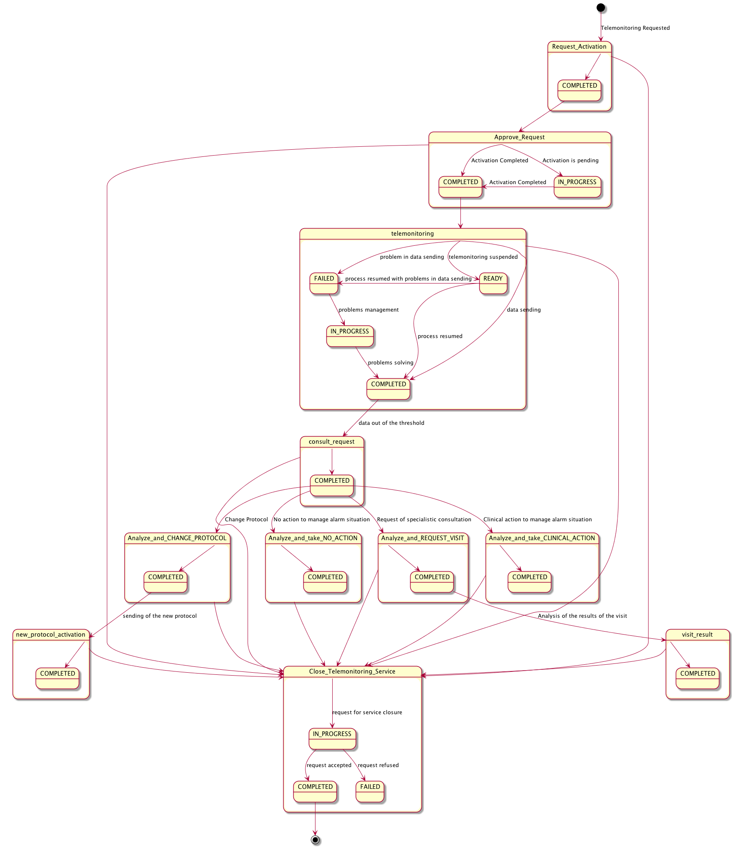

Figure X.2-1: Workflow Definition sample process flow

A telemonitoring process produces many documents and each of these documents is referenced in related tasks of the Workflow Document. Figure X.2-2 and table X.2-1, outlines the documents needed as input and output for each task.



Figure X.2-2: Input and Output Documents of each task

Table X.2-1: Input and Output Documents of each task/status pair

| Task Type | Task Status | Input Docs | Option | Output Docs | Option |
| --- | --- | --- | --- | --- | --- |
| Request Activation | COMPLETED | Clinical Input | O  * These may change if Workflow Options are selected | Request Activation Document | R |
| Approve Request | IN_PROGRESS | Request Activation Document | R | Installation Document | O |
| Clinical Input | O  * These may change if Workflow Options are selected |
| COMPLETED | Request Activation Document | R | Installation Document | O |
| Clinical Input | O  * These may change if Workflow Options are selected |
| Telemonitoring | COMPLETED | N/A | - | Telemonitoring Results Document | R |
| FAILED | N/A | - | Telemonitoring Results Document | R |
| IN_PROGRESS | Telemonitoring Results Document | O | N/A | - |
| READY | N/A | - | N/A | - |
| Consult Request | COMPLETED | Telemonitoring Results Document | R  * These may change if Workflow Options are selected | Request Consult Document | R |
| Analyze and Request Visit | COMPLETED | Telemonitoring Results Document | R  * These may change if Workflow Options are selected | eReferral Workflow Document | R2 |
| Request Consult Document | R | eReferral Document | R2 |
| Consult Note  *This is present if it is not possible to create an eReferral Document and related WD | R2 |
| Visit Result | COMPLETED | Clinical Report of the visit | R2 | Visit Result Document | R2 |
| eReferral Workflow Document | R2 | Consult Note | R2 |
| Analyze and Change Protocol | COMPLETED | Telemonitoring Results Document | R  * These may change if Workflow Options are selected | Updated Telemonitoring Protocol | R |
| Request Consult Document | R | Consult Note | O |
| New Protocol Activation | COMPLETED | Updated Telemonitoring Protocol | R | N/A | - |
| Analyze and Take Clinical Action | COMPLETED | Telemonitoring Results Document | R  * These may change if Workflow Options are selected | Consult Note | O |
| Request Consult Document | R |
| Analyze and Take No Action | COMPLETED | Telemonitoring Results Document | R  * These may change if Workflow Options are selected | Consult Note | O |
| Request Consult Document | R |
| Close Telemonitoring Service | IN_PROGRESS | N/A | - | Request Closing | R |
| FAILED | N/A | - | Refuse Closing | R |
| COMPLETED | N/A | - | Accept Closing | R |

## X.3 Workflow Participants and Process Flow

In this section we present the Workflow Participants involved in the telemonitoring process and, using the figure X.3-1, we describe in detail process transactions and interactions between them.

A Workflow Participant is an abstraction of system along with users involved in the telemonitoring process. They can be identified, based on their roles in the process, as one of three specific participants. Each of these workflow participants has specific rights and duties in the process. They drive the process from one step to another, performing determinate actions on the workflow:

**Care Manager** is the participant that performs the following actions and related tasks:

* Activating the telemonitoring service – task APPROVE REQUEST;
* Creating the Telemonitoring Results Document for each set of data sent – task TELEMONITORING;
* Creating the Request Consult Document in the case of alarm situations – task REQUEST CONSULT;
* Activating new telemonitoring protocol when requested form the General Clinician Manager – Task NEW PROTOCOL ACTIVATION;
* Request of closing for the service or acceptance/refusing of closing for the service when requested by the Consult Manager – task “Close Telemonitoring Service”.

**General Clinician Manager** is the participant that performs the following actions and related tasks:

* Creating the Workflow Document for the telemonitoring of his patient;
* Creating the Request Activation Document – task REQUEST ACTIVATION;

**Consult Manager** is the participant that performs the following actions and related tasks:

* Analyzing any alarm situations and deciding how to manage them – tasks ANALYZE AND REQUEST VISIT, ANALYZE AND CHANGE PROTOCOL, ANALYZE AND TAKE CLINICAL ACTION and ANALYZE AND TAKE NO ACTION;
* If a specialist visit is needed, producing an eReferral Document and creating the related eReferral Workflow Document or a Consult Note – task ANALYZE AND REQUEST VISIT;
* After receive the Clinical Report of the visit by the specialist as the end of the eReferral process, checking the visit’s outcomes and confirming the telemonitoring protocol – task VISIT RESULT;
* If a change of protocol is decided, updating the Telemonitoring Protocol Document – task ANALYZE AND CHANGE PROTOCOL;
* If clinical actions are decided (e.g., change therapy) – task ANALYZE AND TAKE CLINICAL ACTION;
* If no action is decided – task ANALYZE AND TAKE NO ACTION.
* Request of closing for the service or acceptance/refusing of closing for the service when requested by the Care Manager – task “Close Telemonitoring Service”.

Table X.3-1 describes these Workflow Participants.

Table X.3-1: Workflow Participants

| Workflow  Participants | Description |
| --- | --- |
| Care Manager | *Participant responsible for the management of the telemonitored data sent by the patient from his home and of the alarm situations incurring when data go outside of the thresholds* |
| General Clinician Manager | *Participant responsible for the request of activation of the telemonitoring process and producing the telemonitoring Workflow Document* |
| Consult Manager | *Participant responsible for the management of the clinical care process of the patient from the activation of the telemonitoring service with the clinical management of alarm situations reported by the Care Manager* |

The following figure describes the relationship between each Workflow Participants and the tasks of the telemonitoring process.

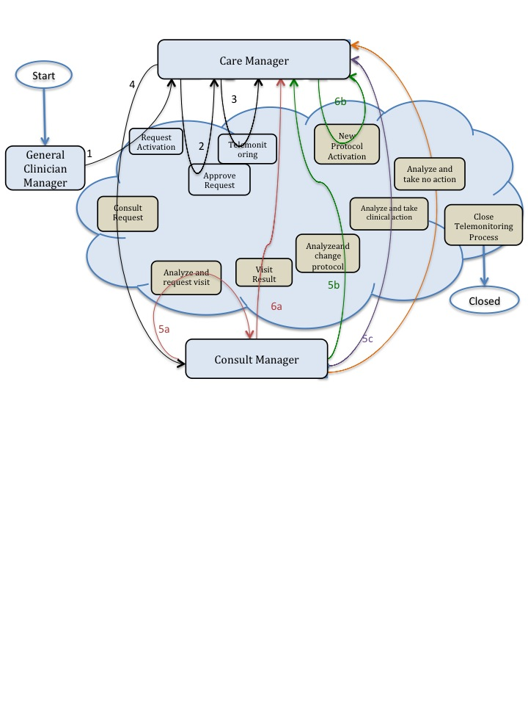Figure X.3-1: Process transaction between Workflow Participants

### X.3.1 Use Cases

Dr. Rossi, a general practitioner, visits his patient, Mr. Jones, who has chronic heart failure.

He decides to include Mr. Jones in a telemonitoring program which monitors the heart rate of the patient, and his O2-saturation. He activates this service by filling in a formal request to the service provider, stating the clinical parameters that have to be monitored (pulse-oximetry and heart rate), the frequency of the patient’s measurements, the threshold values to detect alarm situations, and his contact information to inform the service provider that he is the primary physician who will follow the patient in the service.

At the telemonitoring centre, Mr. Bonning receives the request and approves it: at this point, Mr. Bonning starts scheduling the installation of the devices at the patient’s home.

After the devices are installed and tested, Mr. Jones starts the devices and is being monitored. The measurements and the related data are transmitted to the telemonitoring centre.

A week later, the heart rate measuring device sends an alarm to the telemonitoring centre, indicating a possible atrial fibrillation. Dr. Rossi receives a message from the Telehome monitoring centre; after an analysis of the patient’s data, Dr. Rossi decides to refer Mr. Jones to his cardiologist. After receiving the results of the visit to the cardiologist, Dr. Rossi evaluates that his patient can continue with the scheduled telemonitoring program.

The use case presented in this section, related to the definition of a telemonitoring process workflow, is composed of two parts.

The first one is about the creation of the Workflow Document (WD), which tracks all the events occurring during the telemonitoring process of a patient, and how it is updated with the daily transmission of the patient's clinical data (from step A to C1).

The second part of this use case follows the workflow that occurs when the data sent by the patient goes outside of the thresholds set in the protocol, causing the occurrence of an alarm situation for the patient (from step C2 to step F).

The workflow related to this use case is a multi-step process:

A. The GP requests the telemonitoring service for his chronic patient;

B. The telemonitoring service provider evaluates and accepts the activation request and activates the service for the patient;

C. The patient performs his measurements according to the protocol and transmits them to the telemonitoring service provider. At this point there are two possibilities:

C1. The patient’s measurements are normal and telemonitoring continues;

C2. The patient’s measurements are outside the thresholds defined;

D. The telemonitoring service provider detects an alarm situation for the patient and requests a physician’s consultation;

E. The GP analyses the alarm situation. At this point there are three possibilities:

1. The GP analyses the alarm situation and decides to request a specialist visit for his patient;
2. The GP analyses the alarm situation and decides to change the telemonitoring protocol of his patient, in particular the therapy or the monitoring timing or the alarm thresholds;
3. The GP analyses the alarm situation and decides to perform clinical actions to solve the situation, e.g., change the therapy;
4. The GP analyses the alarm situation and decides to perform no actions.

F. The alarm situation is resolved. At this point there are three possibilities depending on the path chosen at step E:

F1. The GP checks the results of the visit and confirms the new telemonitoring protocol;

F2. The telemonitoring service provider activates the new telemonitoring protocol.

G. Closing of telemonitoring process:

G1. The request of closing is added by the GP and completed by the telemonitoring service provider

G2. The request of closing is added by the telemonitoring service provider and completed by the GP

Each step is now described both from a clinical and a technical point of view.

We present below the detailed chronological sequence of steps.

**A. The GP requests the telemonitoring service for his chronic patient**

In this task, the GP determines that his patient with chronic heart failure needs to be followed by a telemonitoring service allowing him to be monitored remotely as he performs daily measurements of his clinical parameters. The GP requests a service activation to the telemonitoring service provider, creating a document for the formal request (Request Activation Document) including the customized telemonitoring protocol (clinical parameters to collect, frequency of data transmission, threshold values to detect alarm situations, information about the referencing physician and the patient’s therapy) and referencing the reports and results that can be used to evaluate the possibility of a follow up at home.

The GP’s software, or some system acting as a General Clinician Manager, produces the Request Activation Document and one Workflow Document to track the clinical workflow of the patient being followed by the telemonitoring service. As shown in column A of figure X.3.1-2, at this time the Workflow Document has only one task (“Request Activation”) characterized by:

* a status of “Completed”;
* references to Clinical Input as inputs of the task;
* reference to the Request Activation Document as the output of the task.

In order to share the documents produced during the task, the system acting as the General Clinician Manager submits the Request Activation Document and the Workflow Document to an XDS Document Repository.

**B. The telemonitoring service provider evaluates and accepts the activation request and activates the service for the patient**

In order to evaluate the activation request from the GP, the telemonitoring service provider queries for and retrieves the Request Activation Document and the associated Workflow Document using a system which acts as a Care Manager.

If the telemonitoring service provider approves the activation request, as shown in column B of figure X.3.1-2, it updates the Workflow Document with a new version in which a new task “Approve Request” has been added to the content of the previous version. The task “Approve Request” is characterized by:

* a status “Completed”;
* the references to the Request Activation Document produced by the GP and Clinical Input as inputs of the task.

The telemonitoring service provider's system, as a Care Manager, provides the updated version of Workflow Document to the XDS Document Repository/Registry, replacing the previous version.

At this step, there is the possibility for a system of subscription and notification, through the use of the Document Metadata Subscription (DSUB) profile or the Notification of Document Availability (NAV) profile, to notify the GP that performed the request that the patient has been activated.

**C1. The patient performs his measurements according to the protocol and transmits them to the telemonitoring service provider. The patient’s measurements are normal and telemonitoring continues**

The patient is activated with the telemonitoring service. He collects his clinical parameters at home and sends these data to the telemonitoring service provider. The telemonitoring service provider evaluates the data received and includes them in the Telemonitoring Results Document referenced in the Workflow Document.

To accomplish this, the telemonitoring service provider, using a system that acts as a Care Manager, queries and retrieves the Workflow Document and creates the Telemonitoring Results Document.

At this step of the workflow, as shown in column C1 of figure X.3.1-2, the Workflow Document is updated with a new version in which a new task “Telemonitoring n.1” is added to the content of the previous version of the Workflow Document. The task “Telemonitoring n.1” is characterized by:

* a status “Completed”;
* a reference to the Telemonitoring Results Document as output of the task.

The telemonitoring service provider’s software, as a Care Manager, provides the updated version of Workflow Document to the Document Repository, replacing the previous version.

At any time the GP may review the Workflow Document and the new documents produced related to this workflow. This is accomplished through a query and retrieve by the GP’s software of the active Workflow Document from the XDS Document Registry and the XDS Document Repository.

This process is repeated for every data transmission so the Workflow Document is continuously updated and tracks all events and their respective status along with the associated documents, allowing all physicians treating the patient to share and manage the complete workflow of the telemonitoring process any time they need.

Each time the patient performs a measurement this task is created, and there would be the possibility for a system of subscription and notification, through the use of the Document Metadata Subscription (DSUB) profile or the Notification of Document Availability (NAV) profile, to communicate the creation of the task and the related Telemonitoring Results Document to the GP, so that they can access the workflow and view the patient’s data.

Figure X.3.1-1 describes the process flow reporting the related tasks from step A to C1.

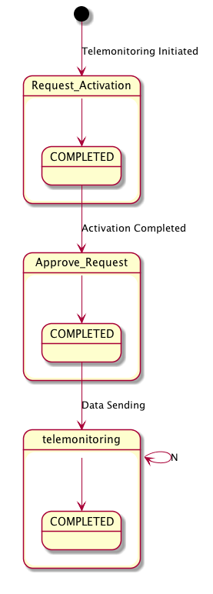

Figure X.3.1-1: Workflow Definition sample process flow

To demonstrate how the Workflow Document is populated during the process, figure X.3.1-2 shows the evolution of the Workflow Document during this telemonitoring workflow from step A to step C1. Each one of the steps is depicted in a column.

Figure X.3.1-2: Management of the Workflow Document from step A to step C1

**C2. The patient performs his measurements according to the protocol and transmits them to the telemonitoring service provider. The patient’s measurements are outside the thresholds defined;**

The patient collects his clinical parameters at home and sends these data to the telemonitoring service provider. The telemonitoring service provider evaluates the data received and includes them in the Telemonitoring Results Document referenced in the Workflow Document.

To accomplish this, the telemonitoring service provider uses a system that acts as Care Manager to query and retrieve the Workflow Document and creates the Telemonitoring Results Document.

At this step of the workflow, the Workflow Document is updated with a new version in which a new task “Telemonitoring n. n+1” is added to the content of the previous version of the Workflow Document. The task “Telemonitoring n. n+1” is characterized by:

* a status “Completed”;
* the reference to the Telemonitoring Results Document as output of the task.

The telemonitoring service provider’s system, as a Care Manager, provides the updated version of Workflow Document to the Document Repository, replacing the previous version.

**D. The telemonitoring service provider detects the alarm situation for the patient and requires a physician’s consultation**

If the data sent by the patient are outside of the normal range defined by the GP in the telemonitoring protocol, the telemonitoring service provider has to manage an alarm situation for the patient.

The telemonitoring service provider needs to alert the referring physician so, using a system that acts as a Care Manager, it creates a Request Consult Document including a request for the physician to evaluate this alarm situation. At the same time the telemonitoring service provider queries and retrieves the Workflow Document.

At this step of the workflow, the Workflow Document is updated with a new version in which a new task, “Consult Request,” is added to the content of the previous version. The task “Consult Request” is characterized by:

* a status “Completed”;
* a reference to the Telemonitoring Results Document as input of the task;
* a reference to the Request Consult Document as output of the task.

The telemonitoring service provider’s software, as a Care Manager, provides the updated version of Workflow Document to the Document Repository, replacing the previous version.

Each time the telemonitoring service provider detects an alarm situation, there is a possibility for a system of subscription and notification through the use of the Document Metadata Subscription (DSUB) profile or the Notification of Document Availability (NAV) profile, to communicate the presence of an alarm to the GP.

**E. The GP analyses the alarm situation**

The physician analyses the alarm situation for the patient by accessing the Workflow Document, using a system that acts as a Consult Manager, to query and retrieve it together with the Telemonitoring Results Document and the Request Consult Document.

Depending on how the GP decides to manage the alarm situation, there are three possible options at this point.

For each of the following cases, when the GP solves the alarm situation, there is a possibility for a system of subscription and notification between tasks, through the use of the Document Metadata Subscription (DSUB) profile or the Notification of Document Availability (NAV) profile, to notify the telemonitoring service provider that the alarm condition has been resolved.

***Case 1***

**E1. The GP analyses the alarm situation and decides to request a specialist visit for his patient;**

If the GP decides that the patient needs to have a specialist visit, he refers the patient to a specialist, creating an eReferral Document and the related eReferral Workflow Document to track the specific events related to the visit, using a system that acts as a Consult Manager.

The Workflow Document is updated with a new task, “Analyze and Request Visit,” which is characterized by:

* a task status “Completed”;
* references to the Telemonitoring Results Document and the Request Consult Document as inputs of the task;
* references to the eReferral Document and the link to the eReferral Workflow Document as outputs.

The GP’s system, as a Consult Manager, provides an updated version of the Workflow Document to the Document Repository, replacing the previous version.

At this time this Workflow will be on standby until the eReferral process is concluded. When the eReferral Workflow Document generated in this task is completed and the report produced by the specialist is returned to the GP, he can decide how to proceed.

For a description of the management of the eReferral Workflow Document, refer to the Cross-enterprise Basic eReferral Workflow Definition Profile (XBeR-WD Profile).

**F1. The alarm situation is resolved. The GP checks the results of the visit and confirm the telemonitoring protocol.**

The physician checks the results of the referral, consulting the Clinical Report referenced in the eReferral Workflow Document. At this time, the Workflow Document related to the telemonitoring process is reactivated by the GP, using a system that acts as a Consult Manager, to notify the telemonitoring service provider that the telemonitoring of the patient can proceed.

The GP creates a Visit Result Document including a description of the visits outcomes and a confirmation that the telemonitoring protocol can continue. This document is included in the Workflow Document as a reference.

The Workflow Document is updated with a new task, “Visit Result,” characterized by:

* a task status “Completed”;
* references to the Clinical Report of the visit from the referral and a link to the eReferral Workflow Document as inputs of the task;
* a reference to the Visit Result Document as output of the task.

The GP’s system, as a Consult Manager, provides the updated version of Workflow Document to the Document Repository, replacing the previous version.

The telemonitoring service provider can then review the Workflow Document and the new documents produced related to this workflow. This is accomplished through a query and retrieve of the active Workflow Document by the telemonitoring service provider’s system from the XDS Document Registry and the XDS Document Repository.

Figure X.3.1-3 describes this process flow and related tasks from step A to F1.

For further technical details see Appendix B.

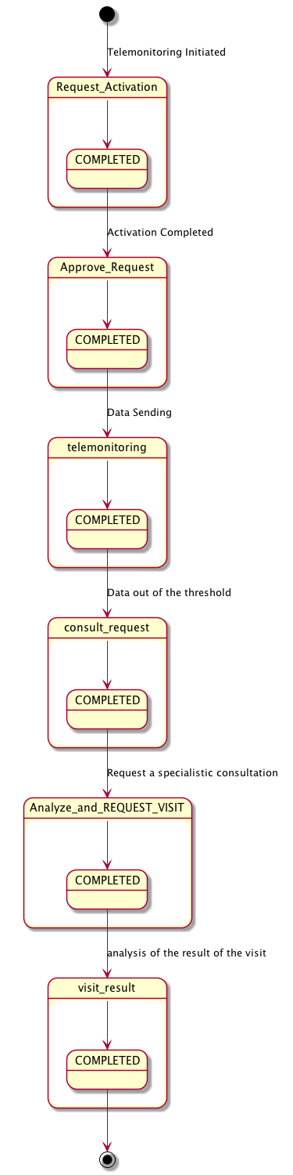

Figure X.3.1-3: Workflow Definition sample process flow

***Case 2***

**E2. The GP analyses the alarm situation and decides to change the telemonitoring protocol of his patient, in particular the therapy or the monitoring timing or the alarm thresholds.**

If the GP decides to change the telemonitoring protocol, including therapy type, telemonitoring timing or alarm thresholds:

* the GP’s system, as a Consult Manager, produces a Telemonitoring Protocol Document, updated with the new telemonitoring protocol;
* the GP’s system updates the Workflow Document.

This step is characterized by the creation of another task, “Analyze and Change Protocol,” related to the telemonitoring protocol change.

In the Workflow Document, the “Analyze and Change Protocol” task is characterized by:

* a task status “Completed”;
* references to the Telemonitoring Results Document and the Request Consult Document as inputs of the task;
* a reference to the Updated Telemonitoring Protocol as output of the task.

The GP’s system, as a Consult Manager, provides the updated version of Workflow Document to the Document Repository, replacing the previous version.

**F2. The alarm situation is resolved. The telemonitoring service provider activates the new telemonitoring protocol.**

After the GP publishes the new telemonitoring protocol and notifies the telemonitoring service provider, the new telemonitoring protocol for the patient must be activated. The telemonitoring service provider retrieves the Updated Telemonitoring Protocol and the associated Workflow Document accessing them using a system that acts as a Care Manager.

Once the telemonitoring service provider activates the new telemonitoring protocol it updates the Workflow Document with a new version in which the task “New Protocol Activation” is updated with the new information. The task “New Protocol Activation” is characterized by:

* a status “Completed”;
* the reference to the Updated Telemonitoring Protocol produced by the GP as input of the task.

The telemonitoring service provider’s system, as a Care Manager, provides the updated version of Workflow Document to the XDS Document Repository/Registry, replacing the previous version.

Other clinicians involved in the care of the patient, e.g., the specialist that visits the patient, can access the Workflow Document to view his complete clinical history in relation to the telemonitoring process.

Figure X.3.1-4 describes the process flow and related tasks from step A to F2.

For further technical details see Appendix B.

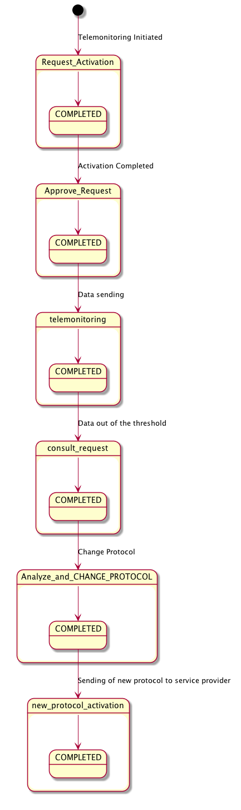

Figure X.3.1-4: Workflow Definition sample process flow

***Case 3***

**E3. The GP analyses the alarm situation and decides to perform clinical actions.**

If the GP decides that the alarm situation requires clinical actions, that include e.g., a change of the patient’s therapy, he updates the Workflow document with a new task, “Analyze and Take Clinical Action”.

In the Workflow Document, the task “Analyze and Take Clinical Action” is characterized by:

* a task status “Completed”;
* references to the Telemonitoring Results Document and the Request Consult Document as inputs of the task.

The GP’s system, as a Consult Manager, provides the updated version of Workflow Document to the Document Repository, replacing the previous version.

Figure X.3.1-5 describes the process flow and related tasks from step A to E3.

For further technical details see Appendix B.

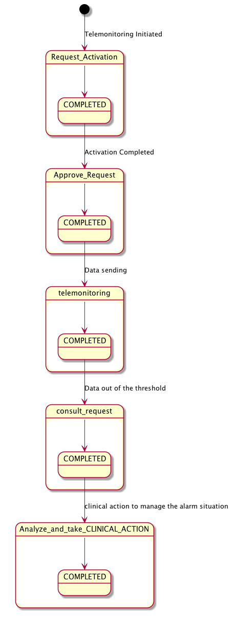

Figure X.3.1-5: Workflow Definition sample process flow

***Case 4***

**E4. The GP analyses the alarm situation and decides to perform no actions.**

If the GP decides that the alarm situation requires no action, he updates the Workflow document with a new task, “Analyze and Take No Action”.

In the Workflow Document, the task “Analyze and Take No Action” is characterized by:

* a task status “Completed”;
* references to the Telemonitoring Results Document and the Request Consult Document as inputs of the task.

The GP’s system, as a Consult Manager, provides the updated version of Workflow Document to the Document Repository, replacing the previous version.

Figure X.3.1-6 describes the process flow and related tasks from step A to E4.

For further technical details see Appendix B.

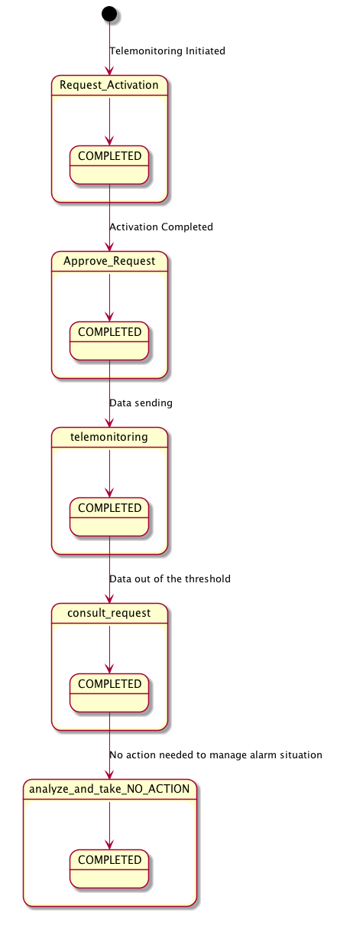

Figure X.3.1-6: Workflow Definition sample process flow

**G. Closing of telemonitoring process**

The GP or the telemonitoring service provider proposes the closing of the telemonitoring process for the patient for many possible reasons, e.g., the patient is not able anymore to use the medical device to be remotely monitored, the patient is not considered eligible anymore for the telemonitoring service, the patient is deceased or must be hospitalized for long time, etc.

There are two possible cases to manage the closing of telemonitoring process.

G1. The requestof closing is added by the GP and completed by the telemonitoring service provider

The GP decides that the patient doesn’t need to be monitored anymore by the telemonitoring service:

* the GP’s system, as a Consult Manager, produces a Request of Closing;
* the GP’s system updates the Workflow Document.

This step is characterized by the creation of the task, “Close Telemonitoring Service”.

In the Workflow Document, the “Close Telemonitoring Service” task is characterized by:

* a task status “In Progress”;
* a reference to the Request of Closing as output of the task.

The GP’s system, as a Consult Manager, provides the updated version of Workflow Document, replacing the previous version.

After the acknowledgment of the Request of Closing and the creation of a document to track the reasons of closure’s acceptance, the telemonitoring service provider updates the Workflow Document changing the task “Close Telemonitoring Service” characterized by:

* a task status “Completed”;
* a reference to the Acceptance Of Closing as output of the task.

The telemonitoring service provider’s system, as a Care Manager, provides the updated version of Workflow Document to the XDS Document Repository/Registry, replacing the previous version.

G2. The request of closing is added by the telemonitoring service provider and completed by the GP

The telemonitoring service provider decides that the patient doesn’t need to be monitored anymore by the telemonitoring service:

* the telemonitoring service provider’s system, as a Care Manager, produces a Request of Closing;
* the telemonitoring service provider’s system updates the Workflow Document.

This step is characterized by the creation of the task, “Close Telemonitoring Service”.

In the Workflow Document, the “Close Telemonitoring Service” task is characterized by:

* a task status “In Progress”;
* a reference to the Request of Closing as output of the task.

The telemonitoring service provider’s system, as a Care Manager, provides the updated version of Workflow Document to the Document Repository, replacing the previous version.

After the acknowledgment of the Request of Closing and the creation of a document to track the reasons of closure’s acceptance, the GP updates the Workflow Document changing the task “Close Telemonitoring Service” characterized by:

* a task status “Completed”;
* a reference to the Acceptance Of Closing as output of the task.

The GP’s system, as a Consult Manager, provides the updated version of Workflow Document to the XDS Document Repository/Registry, replacing the previous version.

It would also be possible for a system of subscription and notification to communicate the progress between the different steps through the use of the Document Metadata Subscription (DSUB) profile or the Notification of Document Availability (NAV) profile.

### X.3.2 Options

In this section we describe which variations from the normal process are allowed. It is mandatory for implementers to explicitly define which workflow options, if any, are addressed by their products (See section 4).

Options that may be selected for this Profile are listed below along with the Workflow Participants to which they apply.

This Workflow Definition Profile is intended to be combined with other IHE Profiles. These other profiles may have their specific options. These are not addressed in this section, which focuses only on the Options identified for this Workflow Definition Profile.

#### X.3.2.1 Consult Request task without Telemonitoring task as ancestor Option

The process can develop without the requirement to have the Telemonitoring task with data out of threshold as ancestor of the task Consult Request. This allows this profile to be implemented in many other real use-cases. If the “Consult Request task without Telemonitoring task as ancestor option” is chosen, rules to manage the process shall change.

If this workflow definition option is implemented, e.g., if the Care Manager is a single system that collects and manages data, when collected data are out of threshold, the Care Manager creates directly the Consult Request task with the Request Consult Document including the alarm information together with the clinical parameters of interest; this, without creating previously the Telemonitoring task that is not needed because it should include a document with the same information.

These rule changes are addressed in the Task Specification section Y.3:

* Task “Consul Request”:
* Task dependencies:
* Ancestors: Approve Request, Telemonitoring of a previous data collection without alarms, Visit Result, New protocol activation, Analyze and Take Clinical Action, Analyze and Take No Action.
* Input
* None
* Task “Analyze and Request Visit”:
* Input
* Request Consult Document (Required)
* Task “Analyze and Change Protocol”:
* Input
* Request Consult Document (Required)
* Task “Analyze and Take Clinical Action”:
* Input
* Request Consult Document (Required)
* Task “Analyze and Take No Action”:
* Input
* Request Consult Document (Required)

#### X.3.2.2 Clinical Input Option

If this option is selected it is required that a Clinical Input is referenced as input of the tasks Request Activation and Approve Request.

## X.4 Workflow Definition Actors and Options

Workflow Participants introduced in Section X.3 are expected to be supported by Workflow Definition Actors that represents abstractions of IT systems. Compliance to this workflow definition profile and its options are based on selecting the implementation of one or more of these Workflow Definition Actors.

### X.4.1 Workflow Definition Actors

Table X.4.1-1 specifies the mapping of Workflow Participants to Workflow Definition Actors.

Table X.4.1-1: XTHM-WD Workflow Participants grouping with Workflow Definition Actors

| Workflow Participant | Workflow Definition Actor |
| --- | --- |
| Care Manager | Care Manager Actor |
| General Clinician Manager | General Clinician Manager Actor |
| Consult Manager | Consult Manager Actor |

### X.4.2 Workflow Options

Options that may be selected for this Profile are listed below along with the Workflow Definition Actors to which they apply. Although this Workflow Definition Profile is intended to be combined with other IHE Profiles, the specific options of these other Profiles are not addressed in this section, which focuses only on the Options identified for this Workflow Definition Profile.

Table X.4.2-1 specifies the options that are available, if any for each selected Workflow Definition Actors.

Table X.4.2-1: XTHM Profile Workflow Definition Actors and Options

| XTHM-WD Workflow Definition Actor | option | Volume & Section |
| --- | --- | --- |
| Care Manager Actor | *Consult Request task without Telemonitoring task as ancestor Option*  *Clinical Input Option* | PCC TF-1: X.3.2.1  PCC TF-1: X.3.2.2 |
| General Clinician Manager Actor | *Clinical Input Option* | PCC TF-1: X.3.2.2 |
| Consult Manager Actor | *Consult Request task without Telemonitoring task as ancestor Option* | PCC TF-1: X.3.2.1 |

### X.4.3 Workflow Definition Profile Grouping with other Profiles

This Workflow Definition Profile is intended to be combined with other IHE Profiles. The profiles that are candidates for such combinations and the associated rules are specified in this Section.

Figure X.4.3-1 presents an overview for the major classes of IHE Profiles that shall or may be grouped:

* The Workflow Definition Profile SHALL be grouped with the XDW Profile.
* The Workflow Definition Profile SHOULD be grouped with one or more Document Content Profiles matched to the input and output reference “Document Labels” in the Workflow Definition Profile (defined in Vol.2). The Workflow Definition Profile provides only “Document Labels” for these input and output reference documents and not the actual specifications. This selection of the actual document content specification (IHE Content profiles or others), need to be made by the environment that deploys the Workflow Definition Profile.
* The Workflow Definition Profile, the XDW Profile and the selected Document Content Profiles shall be grouped as decided by the deployment environment, with the suitable Integration Profile supporting a document transport service such as XDS for Document Sharing, XDR/XDM for point-to-point directed transport, or other functionally equivalent profiles.
* Consult Manager Actor of the XTHM-WD Profile SHALL be grouped with Referral Requester Actor of XBeR-WD Profile.

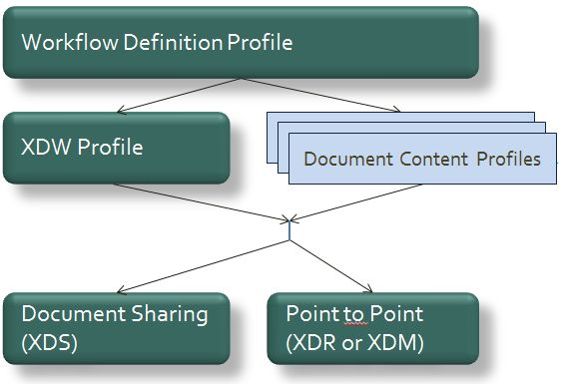

Figure X.4.3-1: Grouping of profiles

The grouping of XDW actors with each of the XTHM-WD Workflow Definition Actors is specified in table X.4.3-1. These XDW Actors support the creation, consumption and update of the XDW workflow document which is the shared data structure which is tracking the evolution of the workflow. This allows the XTHM-WD Workflow Definition Actors, at any point in the workflow to access the most current status of the workflow and share the tasks performed with all other Workflow Definition Actors.

Note: See IHE ITI TF-1: Section 30.3 (XDW Supplement) for other groupings that are needed for the XDW Actors to permit sharing of a Workflow Document with IHE XDS, XDR or XDM Profiles.

Table X.4.3-1: XTHM-WD Workflow Definition Actors grouping with XDW Actors

|  |  |
| --- | --- |
| Workflow Definition Actor | Shall be grouped with XDW Actors |
| Care Manager Actor | XDW Content Consumer  XDW Content Updater |
| General Clinician Manager Actor | XDW Content Creator  XDW Content Consumer |
| Consult Manager Actor | XDW Content Consumer  XDW Content Updater |

## X.5 Security Considerations

For this section please refer to the section ITI TF-1: 30.5.

Volume 2 – Content Modules

## XTHM Workflow Definition - XDW Workflow Document – Common Attributes

This workflow definition profile is assigned a specific OID that shall be used to assign an identifier to the workflowDefinitionReference element of a Workflow Document that tracks a telemonitoring process.

Table Y.1-1: XTHM-WD Workflow – Workflow Definition Reference

|  |  |
| --- | --- |
| type of Workflow | Workflow Definition Reference |
| Telemonitoring workflow | 1.3.6.1.4.1.19376.1.5.3.1.5.2 |

The XTHM-WD Workflow Definition does not introduce new metadata and all the metadata elements used are the common XDS document metadata specified in ITI TF-3:4.1.5 and in ITI TF-3:5.4.6. In this section only the use of some specific metadata for use of XDW in the XTHM-WD context is specified.

Table Y.1-2: XTHM-WD Workflow – XDS Metadata Attribute

| XDS Metadata Attribute | Definition |
| --- | --- |
| typeCode | For the Workflow Document which tracks the XTHM-WD process the code for the typeCode shall be:  This code will be assigned by LOINC |
| classCode | For the Workflow Document which tracks the XTHM-WD process the code for the classCode is defined by the XDW profile.  See XDW Supplement Section 5.4.6.1 |
| eventCodeList | **Rule 1:**  An XTHM-WD workflow shall be created with code OPEN and shall remain in this status until it is set to CLOSE.  **Rule 2:**  An XTHM-WD workflow should be set to CLOSE when there is the need to end the telemonitoring workflow for any reason. This is done when the status of the task “CloseTelemonitoringService” is moved to COMPLETED  **Rule 3:**  An XTHM-WD workflow that was set to CLOSE can be reopened and set to OPEN if the patient has a need to use the telemonitoring service again.  See IHE ITI TF-3: 5.4.5.7 for a general description of this attribute. |
| serviceStartTime | Is the time at which work began on the first task for this workflow. |
| serviceStopTime | Is the time at which the status of the overall Workflow is changed from OPEN to CLOSED.  It shall be empty when the workflow is still in OPEN state. |

## Y.2 XDW Content Modules

The main instrument of the Cross-enterprise TeleHomeMonitoring Workflow Definition Profile is the Workflow Document defined in the XDW Profile. This document does not include clinical information about the patient directly. It shall only contain information necessary for organizing and defining work tasks. All clinical information regarding any task shall be provided through separate documents that are referenced from the associated input or output documents.

Detailed knowledge of the Cross-enterprise Document Workflow (XDW) profile is indispensable in understanding the following sections. For more detailed, refer to ITI TF-3: 5.4.

## Y.3 Tasks Specifications

Workflow Description Overview:

Table Y.3-1: Workflow Description Overview

| Task Type | Requirement  For task initiation | Task Statuses  *valid when task initiated | Task  Property | Input Docs | Option | Output Docs | Option |
| --- | --- | --- | --- | --- | --- | --- | --- |
| Request Activation | At XDW doc creation | COMPLETED* | Cardinality: 1..1  Removable: no | ClinicalInput | O  * These may change if Workflow Options are selected | RequestActivationDocument | R |
| Approve Request | When Request Activation completed | IN_PROGRESS*  COMPLETED* | Cardinality: 1..1  Removable: no | RequestActivationDocument | R | InstallationDocument | O |
| ClinicalInput | O  * These may change if Workflow Options are selected |
| Telemonitoring | For the first time in the WD: when Approve Request completed | READY*  COMPLETED*  FAILED*  IN PROGRESS | Cardinality: 1..n  Removable: no | N/A |  | TelemonitoringResultsDocument | R |
| Consult Request | If Telemonitoring with data out of the threshold and if there is the need to perform this task in case of alarm | COMPLETED* | Cardinality: 0..n  Removable: no | TelemonitoringResultsDocument | R  * These may change if Workflow Options are selected | RequestConsultDocument | R |
| Analyze and Request Visit | When Consult Request Completed and if there is the need to perform this task in case of alarm | COMPLETED* | Cardinality: 0..n  Removable: no | TelemonitoringResultsDocument | R  * These may change if Workflow Options are selected | eReferralWorkflowDocument | R2 |
| RequestConsultDocument | R | eReferralDocument | R2 |
| ConsultNote   * This is present if it is not possible to create an eReferral Document and related WD | R2 |
| Visit Result | When Request Visit Completed | COMLETED* | Cardinality: 0..n Removable: no | ClinicalReportOfTheVisit | R2 | VisitResultDocument | R2 |
| eReferralWorkflowDocument | R2 | ConsultNote | R2 |
| Analyze and Change Protocol | When Consult Request Completed and if there is the need to perform this task in case of alarm; or after Telemonitoring or Approve Request task if the Consult Manager needs to change the protocol without a related Alarm situation | COMPLETED* | Cardinality: 0..n  Removable: no | TelemonitoringResultsDocument | R  * These may change if Workflow Options are selected | UpdatedTelemonitoringProtocol | R |
| RequestConsultDocument | R | ConsultNote | O |
| New Protocol Activation | When Analyze and Change Protocol completed | COMPLETED* | Cardinality: 0..n  Removable: no | UpdatedTelemonitoring Protocol | R | N/A | - |
| Analyze and Take Clinical Action | When Consult Request Completed and if there is the need to perform this task in case of alarm | COMPLETED* | Cardinality: 0..n  Removable: no | TelemonitoringResultsDocument | R  * These may change if Workflow Options are selected | ConsultNote | O |
| RequestConsultDocument | R |
| Analyze and Take No Action | When Consult Request Completed and if there is the need to perform this task in case of alarm | COMPLETED* | Cardinality: 0..n  Removable: no | TelemonitoringResultsDocument | R  * These may change if Workflow Options are selected | ConsultNote | O |
| RequestConsultDocument | R |
| Close Telemonitoring Service | Not specified | PROGRESS*  COMPLETED  FAILED | Cardinality: 0..n  Removable: no | N/A | - | RequestClosing | R |
| RefuseClosing | C: (If task status is FAILED) |
| AcceptClosing | C: (If task status is COMPLETE) |

In this section we define rules and constraints for the creation and update of the XDW Workflow Document related to the telemonitoring process.

The set of rules defined here is necessary to manage transitions between tasks. For each task the following are defined:

* Task attributes: ID, name, type description;
* The sequence of the tasks: the previous and the next task;
* Which Workflow Participant is allowed to create each task and to change the status;
* The task event;
* The input and output documents.

### Y.3.1 Task: Request Activation

| Task attributes | Rules for the task “Request Activation” |
| --- | --- |
| Task id | Unique id of the instance of the task |
| Task type | **Request Activation** |
| Task name | RequestActivation |
| Task description | Request the activation of the telemonitoring service activation for a patient. |
| Task dependencies | Ancestors: None  Successors: Approve Request, Close Telemonitoring Service |
| Status allowed | **COMPLETED** |
| Status transactions (*) | None, task is created completed.   |  |  |  | | --- | --- | --- | | **Initial Status** | **Final Status** | **eventType** | | none | COMPLETED | create | |
| Input | * Optional   + ClinicalInput (all relevant documents useful to evaluate the possibility for follow up of the patient at home, e.g., clinical or laboratory reports)   * These may change if Workflow Options are selected |
| Output | * Required   + RequestActivationDocument |
| Owner | General Clinician Manager |
| owner changes | No |
| <taskEvent> | Only one |
| Task Removal allowed | May workflow participants remove a task when updating a XDW Workflow Document): No |
| Task duplication | May the task appear more than once in the Workflow Definition: No |

(*) The element eventType stores the type of event that produces the change in the task status. In the “Status transactions” we want to associate the specific type of event to the status transaction produced. For further details on eventType element see XDW profile.

### Y.3.2 Task: Approve Request

| Task attributes | Rules for the task “Approve Request” |
| --- | --- |
| Task id | Unique id of the instance of the task |
| Task type | **Approve Request** |
| Task name | ApproveRequest |
| Task description | Approval of the request for activation for the telemonitoring service. |
| Task dependencies | Ancestors: Request Activation  Successors: Telemonitoring, or Analyze and Change Protocol (if the Consult Manager needs to change the protocol without a related Alarm situation), Close Telemonitoring Service |
| Status allowed | **IN_PROGRESS:** if the enrollment of the patient is pending and needs more information or time to be completed  **COMPLETED:** if the enrollment is completed |
| Status transactions | None, if the task is created in completed state. If the task is created with status IN_PROGRESS, the status shall be changed to COMPLETED when the approving process is completed   |  |  |  | | --- | --- | --- | | **Initial Status** | **Final Status** | **eventType** | | none | IN_PROGRESS | create | | IN_PROGRESS | COMPLETED | complete | | none | COMPLETED | create | |
| Input | * Required   + RequestActivationDocument * Optional   + ClinicalInput   * These may change if Workflow Options are selected |
| Output | * Optional   + InstallationDocument |
| Owner | Care Manager (Approver of the request activation) |
| owner changes | No |
| <taskEvent> | Only one (completed): if the approving process is completed  Two in the other cases |
| Task Removal allowed | May workflow participants remove a task when updating a XDW Workflow Document): No |
| Task duplication | May the task appear more than once in the Workflow Definition: No |

### Y.3.3 Task: Telemonitoring

| Task attributes | Rules for the task “Telemonitoring” |
| --- | --- |
| Task id | Unique id of the instance of the task |
| Task type | **Telemonitoring** |
| Task name | Telemonitoring<N> |
| Task description | Sending of data to the service provider |
| Task dependencies | Ancestors: Approve Request, Telemonitoring, Visit Result, New Protocol Activation, Analyze and Take No Action and Analyze and Take Clinical Action  Successors: Telemonitoring, Consult Request, or Analyze and Change Protocol (if the Consult Manager needs to change the protocol without a related Alarm situation), Close Telemonitoring Service |
| Status allowed | **READY**: if the process is suspended for a period  **or**  **COMPLETED**  **or**  **FAILED:** in case of problems in sending data.  **or**  **IN PROGRESS:** to manage the problems after a status FAILED (not required) |
| Status transactions | None if the task is created with status COMPLETED or FAILED or READY in the case that there is the need to suspend the telemonitoring for a patient at any time in the process. In case of a suspended process, when the process is resumed, the status shall be changed into COMPLETED, or into FAILED if there are problems in sending data when the process is resumed. In case of failing of the Telemonitoring task it is not required to repeat the action traced but it is suggested to solve the problems, occurred in sending data, adding new task Events:   * when the Care Manager takes in charge the problem there is the transaction from status FAILED to status IN_PROGRESS; * when the errors are corrected, there is the transaction from status IN_PROGRESS to status COMPLETED.  |  |  |  | | --- | --- | --- | | **Initial Status** | **Final Status** | **eventType** | | none | COMPLETED | create | | none | READY | suspend | | READY | COMPLETED | resume | | READY | FAILED | fail | | none | FAILED | fail | | FAILED | IN_PROGRESS | resume | | IN_PROGRESS | COMPLETED | complete | |
| Input | * Optional:   + TelemonitoringResultsDocument: if the status is IN_PROGRESS |
| Output | * Required   + TelemonitoringResultsDocument |
| Owner | Care Manager |
| owner changes | No |
| <taskEvent> | Not specified |
| Task Removal allowed | May workflow participants remove a task when updating a XDW Workflow Document): No |
| Task duplication | May the task appear more than once in the Workflow Definition: Yes |

### Y.3.4 Task: Consult Request

| Task attributes | Rules for the task “Consult Request” |
| --- | --- |
| Task id | Unique id of the instance of the task |
| Task type | **Consult Request** |
| Task name | ConsultRequest<N> |
| Task description | Generation of an alarm because data are outside of the thresholds |
| Task dependencies | Ancestors: Telemonitoring with data out of the threshold  * These may change if Workflow Options are selected  Successors: Analyze and Request Visit, Analyze and Change Protocol, Analyze and Take No Action, Analyze and Take Clinical Action, Close Telemonitoring Service |
| Status allowed | **COMPLETED** |
| Status transactions | None, task is created with status completed.   |  |  |  | | --- | --- | --- | | **Initial Status** | **Final Status** | **eventType** | | none | COMPLETED | create | |
| Input | * Required * TelemonitoringResultsDocument   * These may change if Workflow Options are selected |
| Output | * Required   + RequestConsultDocument |
| Owner | Care Manager |
| owner changes | No |
| <taskEvent> | Only one |
| Task Removal allowed | May workflow participants remove a task when updating a XDW Workflow Document): No |
| Task duplication | May the task appear more than once in the Workflow Definition: Yes |

### Y.3.5 Task: Analyze and Request Visit

| Task attributes | Rules for the task “Analyze and Request Visit” |
| --- | --- |
| Task id | Unique id of the instance of the task |
| Task type | **Analyze and Request Visit** |
| Task name | AnalyzeAndRequestVisit<N> |
| Task description | Analysis of the Telemonitoring Results Document and request of a specialist consultation |
| Task dependencies | Ancestors: Consult Request  Successors: Visit Result, Close Telemonitoring Service |
| Status allowed | **COMPLETED** |
| Status transactions | None, task is created with status completed.   |  |  |  | | --- | --- | --- | | **Initial Status** | **Final Status** | **eventType** | | none | COMPLETED | create | |
| Input | * Required * TelemonitoringResultsDocument   * These may change if Workflow Options are selected   * RequestConsultDocument |
| Output | * Required (R2)   + eReferralWorkflowDocument   + eReferralDocument   + ConsultNote |
| Owner | Consult Manager |
| owner changes | No |
| <taskEvent> | Only one |
| Task Removal allowed | May workflow participants remove a task when updating a XDW Workflow Document): No |
| Task duplication | May the task appear more than once in the Workflow Definition: Yes |

### Y.3.6 Task: Visit Result

| Task attributes | Rules for the task “Visit Result” |
| --- | --- |
| Task id | Unique id of the instance of the task |
| Task type | **Visit Result** |
| Task name | VisitResult<N> |
| Task description | Analysis of the Results of the requested eReferral process |
| Task dependencies | Ancestors: Analyze and Request Visit  Successors: Any task to collect or manage telemonitored data or alarms, Close Telemonitoring Service |
| Status allowed | **COMPLETED** |
| Status transactions | None, task is created with status completed.   |  |  |  | | --- | --- | --- | | **Initial Status** | **Final Status** | **eventType** | | none | COMPLETED | create | |
| Input | * Required (R2) * ClinicalReportOfTheVisit * eReferralWorkflowDocument |
| Output | * Required (R2)   + VisitResultDocument   + ConsultNote |
| Owner | Consult Manager |
| owner changes | No |
| <taskEvent> | Only one |
| Task Removal allowed | May workflow participants remove a task when updating a XDW Workflow Document): No |
| Task duplication | May the task appear more than once in the Workflow Definition: Yes |

### Y.3.7 Task: Analyze and Change Protocol

| Task attributes | Rules for the task “Analyze and Change Protocol” |
| --- | --- |
| Task id | Unique id of the instance of the task |
| Task type | **Analyze and Change Protocol** |
| Task name | AnalyzeAndChangeProtocol<N> |
| Task description | Analysis of the alarm situation and change of the telemonitoring protocol |
| Task dependencies | Ancestors: Consult Request, or Telemonitoring or Approve Request (if the Consult Manager needs to change the protocol without a related Alarm situation)  Successors: New Protocol Activation, Close Telemonitoring Service |
| Status allowed | **COMPLETED** |
| Status transactions | None, task is created with status completed.   |  |  |  | | --- | --- | --- | | **Initial Status** | **Final Status** | **eventType** | | none | COMPLETED | create | |
| Input | * Required * TelemonitoringResultsDocument   * These may change if Workflow Options are selected   * RequestConsultDocument |
| Output | * Optional   + ConsultNote * Required   + UpdatedTelemonitoringProtocol |
| Owner | Consult Manager |
| owner changes | No |
| <taskEvent> | Only one |
| Task Removal allowed | May workflow participants remove a task when updating a XDW Workflow Document): No |
| Task duplication | May the task appear more than once in the Workflow Definition: Yes |

### Y.3.8 Task: NewProtocolActivation

| Task attributes | Rules for the task “New Protocol Activation” |
| --- | --- |
| Task id | Unique id of the instance of the task |
| Task type | **New Protocol Activation** |
| Task name | NewProtocolActivation<N> |
| Task description | Analysis of the Updated Telemonitoring Protocol and new protocol activation |
| Task dependencies | Ancestors: Analyze and Change Protocol  Successors: Any task to collect or manage telemonitored data or alarms, Close Telemonitoring Service |
| Status allowed | **COMPLETED** |
| Status transactions | None, task is created in status completed.   |  |  |  | | --- | --- | --- | | **Initial Status** | **Final Status** | **eventType** | | none | COMPLETED | create | |
| Input | * Required * UpdatedTelemonitoringProtocol |
| Output | None |
| Owner | Care Manager |
| owner changes | No |
| <taskEvent> | Only one |
| Task Removal allowed | May workflow participants remove a task when updating a XDW Workflow Document): No |
| Task duplication | May the task appear more than once in the Workflow Definition: Yes |

### Y.3.9 Task: Analyze and Take Clinical Action

| Task attributes | Rules for the task “Analyze and Take Clinical Action” |
| --- | --- |
| Task id | Unique id of the instance of the task |
| Task type | Analyze and Take Clinical Action |
| Task name | AnalyzeAndTakeClinicalAction<N> |
| Task description | Analysis of the alarm situation and clinical actions |
| Task dependencies | Ancestors: Consult Request  Successors: Any task to collect or manage telemonitored data or alarms, Close Telemonitoring Service |
| Status allowed | **COMPLETED** |
| Status transactions | None, task is created in status completed.   |  |  |  | | --- | --- | --- | | **Initial Status** | **Final Status** | **eventType** | | none | COMPLETED | create | |
| Input | * Required * TelemonitoringResultsDocument   * These may change if Workflow Options are selected   * RequestConsultDocument |
| Output | * Optional * ConsultNote |
| Owner | Consult Manager |
| owner changes | No |
| <taskEvent> | Only one |
| Task Removal allowed | May workflow participants remove a task when updating a XDW Workflow Document): No |
| Task duplication | May the task appear more than once in the Workflow Definition: Yes |

### Y.3.10 Task: Analyze and Take No Action

| Task attributes | Rules for the task “Analyze and Take No Action” |
| --- | --- |
| Task id | Unique id of the instance of the task |
| Task type | Analyze and Take No Action |
| Task name | AnalyzeAndTakeNoAction<N> |
| Task description | Analysis of the alarm situation and no actions are necessary |
| Task dependencies | Ancestors: Consult Request  Successors: Any task to collect or manage telemonitored data or alarms, Close Telemonitoring Service |
| Status allowed | **COMPLETED** |
| Status transactions | None, task is created in status completed.   |  |  |  | | --- | --- | --- | | **Initial Status** | **Final Status** | **eventType** | | none | COMPLETED | create | |
| Input | * Required * TelemonitoringResultsDocument   * These may change if Workflow Options are selected   * RequestConsultDocument |
| Output | * Optional * ConsultNote |
| Owner | Consult Manager |
| owner changes | No |
| <taskEvent> | Only one |
| Task Removal allowed | May workflow participants remove a task when updating a XDW Workflow Document): No |
| Task duplication | May the task appear more than once in the Workflow Definition: Yes |

### Y.3.11 Task: Close Telemonitoring Service

| Task attributes | Rules for the task “Close Telemonitoring Service” |
| --- | --- |
| Task id | Unique id of the instance of the task |
| Task type | Close Telemonitoring Service |
| Task name | CloseTelemonitoringService |
| Task description | Closing of the telemonitoring process for the patient |
| Task dependencies | Ancestors: any task of the process  Successors: None if closing is accepted. Telemonitoring, Consult Request, Analyze and Change Protocol if closing is refused. |
| Status allowed | **COMPLETED:** if the closing is accepted  **IN_PROGRESS:** Proposal for closing of the Service  **FAILED:** if the closing is not accepted |
| Status transactions | The task can start with status IN PROGRESS if there is the propose to close the service; if the closing is accepted the status changes in COMPLETED; if closing is not accepted the status changes in FAILED.   |  |  |  | | --- | --- | --- | | Initial Status | Final Status | eventType | | none | IN_PROGESS | create | | IN_PROGRESS | FAILED | fail | | IN_PROGRESS | COMPLETED | complete | |
| Input | none |
| Output | Required  RequestClosing  Optional  AcceptClosing: if status is COMPLETED  RefuseClosing: if status is FAILED |
| Owner | Care Manager and Consult Manager |
| owner changes | Yes, every time. This task needs a double evaluation |
| <taskEvent> | Two. |
| Task Removal allowed | No |
| Task duplication | Yes |

## Y.4 Input and output documents

The WS-HumanTask element that permits to store the reference of an object in input or output sections is described in IHE ITI TF-3:5.4.3.

In table Y.4-1 we define the kind of document involved in the telemonitoring process. For each type of document this table defines the Documents Labels of the document. This Label describes the function or the role that the document performs in the course of the process or during the execution of a task, and defines the type of information conveyed and expected by the owner of the tasks.

Table Y.4-1: Documents involved in the telemonitoring process

| Document Label | Example of Content Profile |
| --- | --- |
| **ClinicalInput** | XDS-SD  PPOC  XD-LAB  ECDR  CIRC  DRPT  APSR |
| **RequestActivationDocument** | XDS-SD |
| **InstallationDocument** | XDS-SD |
| **TelemonitoringResultsDocument** | PHMR  XDS-SD |
| **RequestConsultDocument** | XDS-SD |
| **eReferral** | XDS-SD |
| **ClinicalReportOfTheVisit** | XDS-SD  EDR  PPOC  XD-LAB  ECDR  CIRC  DRPT  APSR |
| **Visit Result Document** | XDS-SD |
| **ConsultNote** | XDS-SD |
| **UpdatedTelemonitoring Protocol** | XDS-SD |
| **RequestClosing** | XDS-SD |
| **AcceptClosing** | XDS-SD |
| **RefuseClosing** | XDS-SD |

Appendix A - Complete example of Telemonitoring Workflow Document

In this Appendix we provide a complete example of a Workflow Document related to the telemonitoring process from the request for service activation and creation of the Workflow Document (WD), through the uploading of daily transmissions of clinical patient data, to the management of an alarm situation with no actions and then with a request of a visit.

|  |
| --- |
| <?xml version="1.0" encoding="UTF-8"?>  <ns3:XDW.WorkflowDocument  xmlns:ns1="urn:hl7-org:v3"  xmlns:ns2="http://docs.oasis-open.org/ns/bpel4people/ws-humantask/types/200803"  xmlns:ns3="urn:ihe:iti:2011:xdw"  xmlns:xsi="http://www.w3.org/2001/XMLSchema-instance"  xsi:schemaLocation="urn:ihe:iti:2011:xdw file:C: XDW-2011-09-13.xsd">  <ns3:id root="1.2.3.4.5"/>  <ns3:effectiveTime value="20120430131000"/>  <ns3:confidentialityCode code="1.24.3.3.3"/>  <ns3:patient>  <ns3:id root="1.3.6.1.4.1.21367.13.20.1000" extension="33333"  assigningAuthorityName="IHERED"/>  </ns3:patient>  <ns3:author>  <ns3:assignedPerson>  <ns1:name>  <ns1:family>Smith</ns1:family>  <ns1:prefix>Mr.</ns1:prefix>  </ns1:name>  </ns3:assignedPerson>  </ns3:author>  <ns3:workflowInstanceID>urn:oid:1.2.3.4</ns3:workflowInstanceID>  <ns3:workflowDocumentSequenceNumber>6</ns3:workflowDocumentSequenceNumber>  <ns3:workflowStatus>OPEN</ns3:workflowStatus>  <ns3:workflowStatusHistory>  <ns3:documentEvent>  <ns3:eventTime>2006-05-04T18:13:51.0Z</ns2:eventTime>  <ns3:eventType>create</ns2:eventType>  <ns3:taskEventIdentifier>urn:oid:1.1</ns2:taskEventIdentifier>  <ns3:author>Mr. Rossi</ns2:author >  <ns3:previousStatus></ns2:previousStatus>  <ns3:actualStatus>OPEN</ns2:actualStatus>  </ns3:documentEvent>  </ns3:workflowStatusHistory>  <ns3:workflowDefinitionReference>urn:oid:1.2.3.4.5.6.7.8.9</ns3:workflowDefinitionReference>  <ns3:TaskList>    <ns3:XDWTask>  <ns3:taskData>  <ns2:taskDetails>  <ns2:id>urn:oid:1.1.1.1.1</ns2:id>  <ns2:taskType>Request Activation</ns2:taskType>  <ns2:name>RequestActivation</ns2:name>  <ns2:status>COMPLETED</ns2:status>  <ns2:createdTime>2012-04-15T08:40:00.0Z</ns2:createdTime>  <ns2:lastModifiedTime>2012-04-15T08:40:00.0Z</ns2:lastModifiedTime>  <ns2:renderingMethodExists>false</ns2:renderingMethodExists>  <ns2:actualOwner>Mr. Rossi</ns2:actualOwner>  <ns2:createdBy>Mr. Rossi</ns2createdBy>  </ns2:taskDetails>  <ns2:description>Request for activation of a telehealth service</ns2:description>  <ns2:input>  <ns2:part name=”ClinicalInput”>  <reference uid=”urn:oid:1.2.3.4.1” home=”urn:oid:1.2.3”/>  </ns2:part>  </ns2:input>  <ns2:output>  <ns2:part name=”RequestActivationDocument”>  <reference uid=”urn:oid:1.2.3.4.2” home=”urn:oid:1.2.3”/>  </ns2:part>  </ns2:output>  </ns3:taskData>  <ns3:taskEventHistory>  <ns3:taskEvent>  <ns3:id>1</ns3:id>  <ns3:eventTime>2012-04-15T08:40:00.0Z</ns3:eventTime>  <ns3:identifier>urn:oid:1.1</ns3:identifier>  <ns3:eventType>create</ns3:eventType>  <ns3:status>COMPLETED</ns3:status>  </ns3:taskEvent>  </ns3:taskEventHistory>  </ns3:XDWTask>  <ns3:XDWTask>  <ns3:taskData>  <ns2:taskDetails>  <ns2:id>urn:oid:1.1.1.1.1</ns2:id>  <ns2:taskType>Approve Request</ns2:taskType>  <ns2:name>ApproveRequest</ns2:name>  <ns2:status>COMPLETED</ns2:status>  <ns2:createdTime>2012-04-17T10:00:00.0Z</ns2:createdTime>  <ns2:lastModifiedTime>2012-04-17T10:00:00.0Z</ns2:lastModifiedTime>  <ns2:renderingMethodExists>false</ns2:renderingMethodExists>  <ns2:actualOwner>Mr. Smith</ns2:actualOwner>  <ns2:createdBy>Mr. Smith</ns2createdBy>  </ns2:taskDetails>  <ns2:description>Request for activation of a telehealth service</ns2:description>  <ns2:input>  <ns2:part name=”RequestActivationDocument”>  <reference uid=”urn:oid:1.2.3.4.2” home=”urn:oid:1.2.3”/>  </ns2:part>  </ns2:input>  </ns3:taskData>  <ns3:taskEventHistory>  <ns3:taskEvent>  <ns3:id>1</ns3:id>  <ns3:eventTime>2012-04-17T10:00:00.0Z</ns3:eventTime>  <ns3:identifier>urn:oid:1.2</ns3:identifier>  <ns3:eventType>create</ns3:eventType>  <ns3:status>COMPLETED</ns3:status>  </ns3:taskEvent>  </ns3:taskEventHistory>  </ns3:XDWTask>  <ns3:XDWTask>  <ns3:taskData>  <ns2:taskDetails>  <ns2:id>urn:oid:1.2.3.4.3</ns2:id>  <ns2:taskType>Telemonitoring</ns2:taskType>  <ns2:name>Telemonitoring1</ns2:name>  <ns2:status>COMPLETED</ns2:status>  <ns2:createdTime>2012-04-20T13:01:50.0Z</ns2:createdTime>  <ns2:lastModifiedTime>2012-04-20T13:01:50.0Z</ns2:lastModifiedTime>  <ns2:renderingMethodExists>false</ns2:renderingMethodExists>  <ns2:actualOwner>Mr. Smith</ns2:actualOwner>  <ns2:createdBy>Mr. Smith</ns2createdBy>  </ns2:taskDetails>  <ns2:description>Sending of data to the service provider</ns2:description>  <ns2:output>  <ns2:part name=”TelemonitoringResultsDocument”>  <reference uid=”urn:oid:1.2.3.4.2” home=”urn:oid:1.2.3”/>  </ns2:part>  </ns2:output>  </ns3:taskData>  <ns3:taskEventHistory>  <ns3:taskEvent>  <ns3:id>1</ns3:id>  <ns3:eventTime>2012-04-20T13:01:50.0Z</ns3:eventTime>  <ns3:identifier>urn:oid:1.3</ns3:identifier>  <ns3:eventType>create</ns3:eventType>  <ns3:status>COMPLETED</ns3:status>  </ns3:taskEvent>  </ns3:taskEventHistory>  </ns3:XDWTask>  <ns3:XDWTask>  <ns3:taskData>  <ns2:taskDetails>  <ns2:id>urn:oid:1.2.3.4.4</ns2:id>  <ns2:taskType>Telemonitoring</ns2:taskType>  <ns2:name>Telemonitoring2</ns2:name>  <ns2:status>COMPLETED</ns2:status>  <ns2:createdTime>2012-04-25T13:11:00.0Z</ns2:createdTime>  <ns2:lastModifiedTime>2012-04-25T13:11:00.0Z </ns2:lastModifiedTime>  <ns2:renderingMethodExists>false</ns2:renderingMethodExists>  <ns2:actualOwner>Mr. Smith</ns2:actualOwner>  <ns2:createdBy>Mr. Smith</ns2createdBy>  </ns2:taskDetails>  <ns2:description>Sending of data to the service provider</ns2:description>  <ns2:output>  <ns2:part name=”TelemonitoringResultsDocument”>  <reference uid=”urn:oid:1.2.3.4.2” home=”urn:oid:1.2.3”/>  </ns2:part>  </ns2:output>  </ns3:taskData>  <ns3:taskEventHistory>  <ns3:taskEvent>  <ns3:id>1</ns3:id>  <ns3:eventTime>2012-04-25T13:11:00.0Z</ns3:eventTime>  <ns3:identifier>urn:oid:1.4</ns3:identifier>  <ns3:eventType>create</ns3:eventType>  <ns3:status>COMPLETED</ns3:status>  </ns3:taskEvent>  </ns3:taskEventHistory>  </ns3:XDWTask>  <ns3:XDWTask>  <ns3:taskData>  <ns2:taskDetails>  <ns2:id>urn:oid:1.2.3.4.5</ns2:id>  <ns2:taskType>Consult Request</ns2:taskType>  <ns2:name>ConsultRequest1</ns2:name>  <ns2:status>COMPLETED</ns2:status>  <ns2:createdTime>2012-04-25T14:01:30.0Z</ns2:createdTime>  <ns2:lastModifiedTime>2012-04-25T14:01:30.0Z</ns2:lastModifiedTime>  <ns2:renderingMethodExists>false</ns2:renderingMethodExists>  <ns2:actualOwner>Mr. Smith</ns2:actualOwner>  <ns2:createdBy>Mr. Smith</ns2createdBy>  </ns2:taskDetails>  <ns2:description>Generation of an alarm because data are out of the threshold </ns2:description>  <ns2:input>  <ns2:part name=”TelemonitoringResultsDocument”>  <reference uid=”urn:oid:1.2.3.4.2” home=”urn:oid:1.2.3”/>  </ns2:part>  </ns2:input>  <ns2:output>  <ns2:part name=”RequestConsultDocument”>  <reference uid=”urn:oid:1.2.3.4.2” home=”urn:oid:1.2.3”/>  </ns2:part>  </ns2:output>  </ns3:taskData>  <ns3:taskEventHistory>  <ns3:taskEvent>  <ns3:id>1</ns3:id>  <ns3:eventTime>2012-04-25T14:01:30.0Z </ns3:eventTime>  <ns3:identifier>urn:oid:1.5</ns3:identifier>  <ns3:eventType>create</ns3:eventType>  <ns3:status>COMPLETED</ns3:status>  </ns3:taskEvent>  </ns3:taskEventHistory>  <ns3:XDWTask>  <ns3:XDWTask>  <ns3:taskData>  <ns2:taskDetails>  <ns2:id>urn:oid:1.2.3.4.6</ns2:id>  <ns2:taskType>Analyze and take no Action</ns2:taskType>  <ns2:name> AnalyzeAndTakeNoAction1</ns2:name>  <ns2:status>COMPLETED</ns2:status>  <ns2:createdTime>2012-04-27T17:56:07.0Z</ns2:createdTime>  <ns2:lastModifiedTime>2012-04-27T17:56:07.0Z</ns2:lastModifiedTime>  <ns2:renderingMethodExists>false</ns2:renderingMethodExists>  <ns2:actualOwner>Mr. Rossi</ns2:actualOwner>  <ns2:createdBy>Mr. Rossi</ns2createdBy>  </ns2:taskDetails>  <ns2:description>Analysis of the Telemonitoring Results Document and no actions are necessary</ns2:description>  <ns2:input>  <ns2:part name=”TelemonitoringResultsDocument”>  <reference uid=”urn:oid:1.2.3.4.2” home=”urn:oid:1.2.3”/>  </ns2:part>  <ns2:part name=”RequestConsultDocument”>  <reference uid=”urn:oid:1.2.3.4.2” home=”urn:oid:1.2.3”/>  </ns2:part>  </ns2:input>  </ns3:taskData>  <ns3:taskEventHistory>  <ns3:taskEvent>  <ns3:id>1</ns3:id>  <ns3:eventTime>2012-04-27T17:56:07.0Z</ns3:eventTime>  <ns3:identifier>urn:oid:1.6</ns3:identifier>  <ns3:eventType>create</ns3:eventType>  <ns3:status>COMPLETED</ns3:status>  </ns3:taskEvent>  </ns3:taskEventHistory>  </ns3:XDWTask>  <ns3:XDWTask>  <ns3:taskData>  <ns2:taskDetails>  <ns2:id>urn:oid:1.2.3.4.7</ns2:id>  <ns2:taskType>Telemonitoring</ns2:taskType>  <ns2:name>Telemonitoring3</ns2:name>  <ns2:status>COMPLETED</ns2:status>  <ns2:createdTime>2012-04-30T13:10:00.0Z</ns2:createdTime>  <ns2:lastModifiedTime>2012-04-30T13:10:00.0Z</ns2:lastModifiedTime>  <ns2:renderingMethodExists>false</ns2:renderingMethodExists>  <ns2:actualOwner>Mr. Smith</ns2:actualOwner>  <ns2:createdBy>Mr. Smith</ns2createdBy>  </ns2:taskDetails>  <ns2:description>Sending of data to the service provider</ns2:description>  <ns2:output>  <ns2:part name=”TelemonitoringResultsDocument”>  <reference uid=”urn:oid:1.2.3.4.2” home=”urn:oid:1.2.3”/>  </ns2:part>  </ns2:output>  </ns3:taskData>  <ns3:taskEventHistory>  <ns3:taskEvent>  <ns3:id>1</ns3:id>  <ns3:eventTime>2012-04-30T13:10:00.0Z</ns3:eventTime>  <ns3:identifier>urn:oid:1.7</ns3:identifier>  <ns3:eventType>create</ns3:eventType>  <ns3:status>COMPLETED</ns3:status>  </ns3:taskEvent>  </ns3:taskEventHistory>  </ns3:XDWTask>  <ns3:XDWTask>  <ns3:taskData>  <ns2:taskDetails>  <ns2:id>urn:oid:1.2.3.4.8</ns2:id>  <ns2:taskType>Consult Request</ns2:taskType>  <ns2:name>ConsultRequest2</ns2:name>  <ns2:status>COMPLETED</ns2:status>  <ns2:createdTime>2012-04-30T11:00:00.0Z</ns2:createdTime>  <ns2:lastModifiedTime>2012-04-30T11:00:00.0Z</ns2:lastModifiedTime>  <ns2:renderingMethodExists>false</ns2:renderingMethodExists>  <ns2:actualOwner>Mr. Smith</ns2:actualOwner>  <ns2:createdBy>Mr. Smith</ns2createdBy>  </ns2:taskDetails>  <ns2:description>Generation of an alarm because data are out of the threshold </ns2:description>  <ns2:input>  <ns2:part name=”TelemonitoringResultsDocument”>  <reference uid=”urn:oid:1.2.3.4.2” home=”urn:oid:1.2.3”/>  </ns2:part>  </ns2:input>  <ns2:output>  <ns2:part name=”RequestConsultDocument”>  <reference uid=”urn:oid:1.2.3.4.2” home=”urn:oid:1.2.3”/>  </ns2:part>  </ns2:output>  </ns3:taskData>  <ns3:taskEventHistory>  <ns3:taskEvent>  <ns3:id>1</ns3:id>  <ns3:eventTime>2012-04-30T11:00:00.0Z<ns3:eventTime>  <ns3:identifier>urn:oid:1.8</ns3:identifier>  <ns3:eventType>create</ns3:eventType>  <ns3:status>COMPLETED</ns3:status>  </ns3:taskEvent>  </ns3:taskEventHistory>  <ns3:XDWTask>  <ns3:XDWTask>  <ns3:taskData>  <ns2:taskDetails>  <ns2:id>urn:oid:1.2.3.4.9</ns2:id>  <ns2:taskType>Analyze and Request Visit</ns2:taskType>  <ns2:name>AnalyzeAndRequestVisit1</ns2:name>  <ns2:status>COMPLETED</ns2:status>  <ns2:createdTime>2012-05-3T08:30:00.0Z</ns2:createdTime>  <ns2:lastModifiedTime>2012-05-3T08:30:00.0Z</ns2:lastModifiedTime>  <ns2:renderingMethodExists>false</ns2:renderingMethodExists>  <ns2:actualOwner>Mr. Rossi</ns2:actualOwner>  <ns2:createdBy>Mr. Rossi</ns2createdBy>  </ns2:taskDetails>  <ns2:description>Analysis of the Telemonitoring Results Document and request of a specialist consultation</ns2:description>  <ns2:input>  <ns2:part name=”TelemonitoringResultsDocument”>  <reference uid=”urn:oid:1.2.3.4.2” home=”urn:oid:1.2.3”/>  </ns2:part>  <ns2:part name=”RequestConsultDocument”>  <reference uid=”urn:oid:1.2.3.4.2” home=”urn:oid:1.2.3”/>  </ns2:part>  </ns2:input>  <ns2:output>  <ns2:part name=”eReferralDocument”>  <reference uid=”urn:oid:1.2.3.4.2” home=”urn:oid:1.2.3”/>  </ns2:part>  <ns2:part name=”XDSFolder.uniqueId”>  <reference uid=”urn:oid:1.2.3.4.2” home=”urn:oid:1.2.3”/>  </ns2:part>  </ns2:output>  </ns3:taskData>  <ns3:taskEventHistory>  <ns3:taskEvent>  <ns3:id>1</ns3:id>  <ns3:eventTime>2012-05-3T08:30:00.0Z</ns3:eventTime>  <ns3:identifier>urn:oid:1.9</ns3:identifier>  <ns3:eventType>create</ns3:eventType>  <ns3:status>COMPLETED</ns3:status>  </ns3:taskEvent>  </ns3:taskEventHistory>  </ns3:XDWTask>  <ns3:XDWTask>  <ns3:taskData>  <ns2:taskDetails>  <ns2:id>urn:oid:1.2.3.4.10</ns2:id>  <ns2:taskType>Visit Result</ns2:taskType>  <ns2:name>VisitResult1</ns2:name>  <ns2:status>COMPLETED</ns2:status>  <ns2:createdTime>2012-05-7T08:30:00.0Z</ns2:createdTime>  <ns2:lastModifiedTime>2012-05-7T08:30:00.0Z</ns2:lastModifiedTime>  <ns2:renderingMethodExists>false</ns2:renderingMethodExists>  <ns2:actualOwner>Mr. Rossi</ns2:actualOwner>  <ns2:createdBy>Mr. Rossi</ns2createdBy>  </ns2:taskDetails>  <ns2:description>Analysis of the Results of the eReferral process requested </ns2:description>  <ns2:input>  <ns2:part name=”ClinicalReport”>  <reference uid=”urn:oid:1.2.3.4.2” home=”urn:oid:1.2.3”/>  </ns2:part>  <ns2:part name=”XDSFolder.uniqueId”>  <reference uid=”urn:oid:1.2.3.4.2” home=”urn:oid:1.2.3”/>  </ns2:part>  </ns2:input>  <ns2:output>  <ns2:part name=”VisitResultDocument”>  <reference uid=”urn:oid:1.2.3.4.2” home=”urn:oid:1.2.3”/>  </ns2:part>  </ns2:output>  </ns3:taskData>  <ns3:taskEventHistory>  <ns3:taskEvent>  <ns3:id>1</ns3:id>  <ns3:eventTime>2012-05-7T08:30:00.0Z</ns3:eventTime>  <ns3:identifier>urn:oid:1.10</ns3:identifier>  <ns3:eventType>create</ns3:eventType>  <ns3:status>COMPLETED</ns3:status>  </ns3:taskEvent>  </ns3:taskEventHistory>  </ns3:XDWTask>  <ns3:XDWTask>  <ns3:taskData>  <ns2:taskDetails>  <ns2:id>urn:oid:1.2.3.4.11</ns2:id>  <ns2:taskType>Telemonitoring</ns2:taskType>  <ns2:name>Telemonitoring4</ns2:name>  <ns2:status>FAILED</ns2:status>  <ns2:createdTime>2012-05-8T09:36:00.0Z</ns2:createdTime>  <ns2:lastModifiedTime>2012-05-8T09:36:00.0Z</ns2:lastModifiedTime>  <ns2:renderingMethodExists>false</ns2:renderingMethodExists>  <ns2:actualOwner>Mr. Smith</ns2:actualOwner>  <ns2:createdBy>Mr. Smith</ns2createdBy>  </ns2:taskDetails>  <ns2:description>Sending of data to the service provider</ns2:description>  <ns2:output>  <ns2:part name=”TelemonitoringResultsDocument”>  <reference uid=”urn:oid:1.2.3.4.2” home=”urn:oid:1.2.3”/>  </ns2:part>  </ns2:output>  </ns3:taskData>  <ns3:taskEventHistory>  <ns3:taskEvent>  <ns3:id>1</ns3:id>  <ns3:eventTime>2012-05-8T09:36:00.0Z</ns3:eventTime>  <ns3:identifier>urn:oid:1.11</ns3:identifier>  <ns3:eventType>fail</ns3:eventType>  <ns3:status>FAILED</ns3:status>  </ns3:taskEvent>  </ns3:taskEventHistory>  </ns3:XDWTask>  <ns3:XDWTask>  <ns3:taskData>  <ns2:taskDetails>  <ns2:id>urn:oid:1.1.1.1.1</ns2:id>  <ns2:taskType>Close Telemonitoring Service</ns2:taskType>  <ns2:name>CloseTelemonitoringService</ns2:name>  <ns2:status>COMPLETED</ns2:status>  <ns2:createdTime>2012-04-15T07:40:00.0Z</ns2:createdTime>  <ns2:lastModifiedTime>2012-04-15T08:40:00.0Z</ns2:lastModifiedTime>  <ns2:renderingMethodExists>false</ns2:renderingMethodExists>  <ns2:actualOwner>Dr. Rossi</ns2:actualOwner>  <ns2:createdBy>Dr. Bianchi</ns2createdBy>  </ns2:taskDetails>  <ns2:description>Viene richiesta la chiusura del servizio</ns2:description>  <ns2:output>  <ns2:part name=”RequestClosing”>  <reference uid=”urn:oid:1.2.3.4.1” home=”urn:oid:1.2.3”/>  </ns2:part>  <ns2:part name=”AcceptClosing”>  <reference uid=”urn:oid:1.2.3.4.2” home=”urn:oid:1.2.3”/>  </ns2:part>  </ns2:output>  </ns3:taskData>  <ns3:taskEventHistory>  <ns3:taskEvent>  <ns3:id>1</ns3:id>  <ns3:eventTime>2012-04-15T07:40:00.0Z</ns3:eventTime>  <ns3:identifier>urn:oid:1.1</ns3:identifier>  <ns3:eventType>create</ns3:eventType>  <ns3:status>IN_PROGRESS</ns3:status>  </ns3:taskEvent>  <ns3:taskEvent>  <ns3:id>1</ns3:id>  <ns3:eventTime>2012-04-15T08:40:00.0Z</ns3:eventTime>  <ns3:identifier>urn:oid:1.1</ns3:identifier>  <ns3:eventType>complete</ns3:eventType>  <ns3:status>COMPLETED</ns3:status>  <ns3:startOwner>Dr. Bianchi</ns3:startOwner>  <ns3:endOwner>Dr. Bianchi</ns3:endOwner>  </ns3:taskEvent>  </ns3:taskEventHistory>  </ns3:XDWTask>  </ns3:TaskList>  </ns3:XDW.WorkflowDocument> |

Appendix B - Technical development of WD related to the telemonitoring process

In this Appendix we present more technical information related to the use-case scenario described in Volume 1 of this profile.

B.1 Management of alarm situation with a request of a visit

Figure B.1-1: Management of the Workflow Document: request of a visit

B.2 Management of alarm situation with a change of the protocol

Figure B.2-1: Management of the Workflow Document: change protocol

B.3 Management of alarm situation with clinical actions



Figure B.3-1: Management of the Workflow Document: clinical actions

B.4 Management of alarm situation with no actions



Figure B.4-1: Management of the Workflow Document: no actions